Time: 2 hr

Guidelines

Must read the problem statement thoroughly before start working .
Create java project using Eclipse only
Create all java classes in package “com.itech” in src folder of created java project
Must follow the class outline as shown in figure
Must follow java coding standards
Make sure your java project must be free from compilation error ,ie. zero compilation error .In case of any compilation error reported ,the project is rejected , will not considered for assessment.
Create a new workspace/folder with name PS-JAVA in either in C: /Users/Ur name
Select that workspace and Create java project with name PS_Name(eg. PS_Rohinth.zip)
Copy that project once you have completed to desktop,zip the folder ( eg. PS_Rohinthj.zip), mail it

Zip Procedure:

1. In eclipse right click on your project.

2. Select copy, then on desktop paste it.

3. Now, on desktop your project folder will be available. Right click that folder and select, send to -> compressed folder.

4. Now you can find compressed file (zip) of your project folder.

Problem Statement

A Cargo Management Services has decided to automate its delivery system. They are in need of a software
to achieve the same. Below are the requirements.

• Add package to a vehicle.
• Fetch the vehicle in which given package is loaded.
• Deliver a package
• Find the packages which are not delivered yet.
• Fetch the count of undelivered packages per vehicle.

Write a program for the above requirement.

Refer the below class diagram and method description to solve the problem. Ensure that attributes are
private and other methods are public.
Cargo can be delivered via air or road ways. Create VehicleDetails class which is inherited by classes
TruckDetails and AirCargoDetails as shown in the below outline.

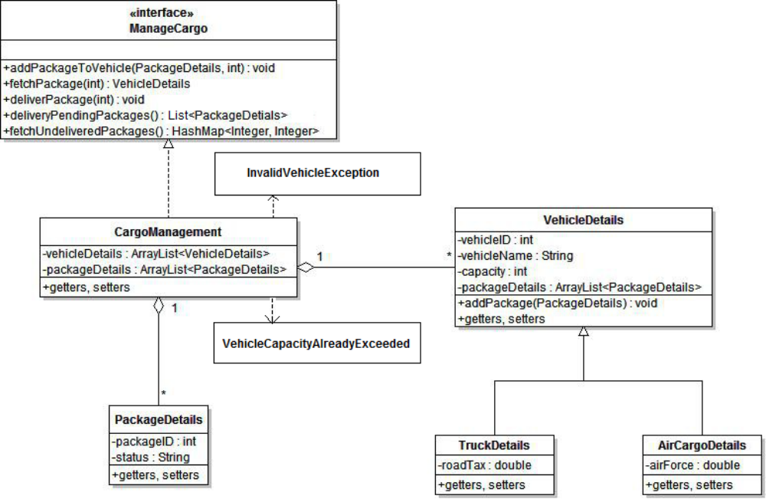

1. addPackageToVehicle :
This method will take the package details object and vehicleId as input and add the package to the
mentioned vehicle.
Following conditions needs to be validated before adding the package.
i. If the mentioned vehicleId is not valid with the system throw InvalidVehicleException.
ii. If the capacity of the mentioned vehicle is already exceeded throw VehicleCapacityAlreadyExceeded
exception.
If the validations are all success, set the status of packaged as “UnDelivered” and add the package to main
package list as well as the list of packages available with the specified vehicleID.

2. fetchPackage:
This method will take packageId as input and return the VehicleDetails in which the package is present.

3. deliverPackage:
This method will take packageId as input and check if the package status is “UnDelivered”. Then the status
will be changed to “Delivered” in the main package list as well as the list of packages available with the
specified vehicleID.

4. deliveryPendingPackages:
This method will return the list of all undelivered packages available in the cargo Management system
arranged in the order of packageID (Use comparable to arrange).

5. fetchUndeliveredPackages:
This method will find out the count of all undelivered packages per vehicle and return in the form of a
hashmap with key as vehicleID and value as count of undelivered packages.

Create class CargoDemo with main method to test functionalities of CargoManagement class.

